Ana Karolyna O. Soares Gama, turma 9 - projeto final

**Tarefa 1: Testando a Teoria**

1. Link para a planilha do Google:

[Ana Karolyna O. Soares Gama, turma 9 - projeto final.xlsx](https://docs.google.com/spreadsheets/d/1rTEHwvVHFsewe_iIawzMArb5MYqT66iO/edit?usp=sharing&ouid=104341148564061708791&rtpof=true&sd=true)

**Tarefa 2: Aplicativo Web Urban.Scooter**

1. Mapa mental (opcional):  
   [Ana Karolyna - Mapa mental - Projeto Final.drawio.pdf](https://drive.google.com/file/d/1SG527uy3ZW_q2MkU2MhR3ix-qYtFNpYy/view?usp=sharing)

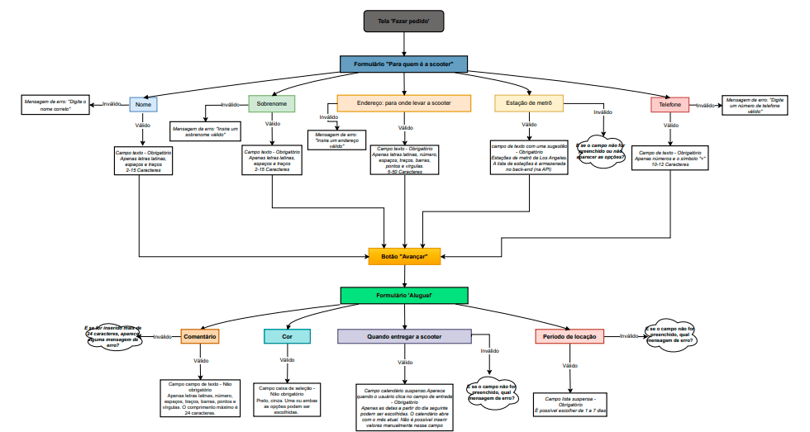

1. Links para os relatórios de bugs feitos no Jira:

[ttps://karolynagama.atlassian.net/issues/?jql=project+%3D+%22URAK%22+ORDER+BY+created+DESC&atlOrigin=eyJpIjoiY2FiYTYwMDUwMmU4NDJiZGJlMThkYjE5YTFmOTNhYzEiLCJwIjoiaiJ9](https://karolynagama.atlassian.net/issues/?jql=project+%3D+%22URAK%22+ORDER+BY+created+DESC&atlOrigin=eyJpIjoiY2FiYTYwMDUwMmU4NDJiZGJlMThkYjE5YTFmOTNhYzEiLCJwIjoiaiJ9)

**Tarefa 3: API do Aplicativo Urban.Scooter**

1. Links para os relatórios de bugs feitos no Jira:

[ttps://karolynagama.atlassian.net/issues/?jql=project+%3D+%22URAK%22+ORDER+BY+created+DESC&atlOrigin=eyJpIjoiY2FiYTYwMDUwMmU4NDJiZGJlMThkYjE5YTFmOTNhYzEiLCJwIjoiaiJ9](https://karolynagama.atlassian.net/issues/?jql=project+%3D+%22URAK%22+ORDER+BY+created+DESC&atlOrigin=eyJpIjoiY2FiYTYwMDUwMmU4NDJiZGJlMThkYjE5YTFmOTNhYzEiLCJwIjoiaiJ9)